Assignment 04
PS490 Research Studies

Directions: Be sure to save an electronic copy of your answer before submitting it to Ashworth College for grading. Unless otherwise stated, answer in complete sentences, and be sure to use correct English, spelling, and grammar. Sources must be cited in APA format. Your response should be double‐spaced; refer to the “Format Requirementsʺ page for specific format requirements.

Submit an Annotated Bibliography of at least 10 sources for your paper, including books, peer-reviewed articles, audio or video materials. Refer to the Lecture Notes about Annotated Bibliography.

Grading Rubric

Please refer to the rubric below for the grading criteria for this assignment.

Additional Readings

DIRECTIONS: To access ProQuest articles, you MUST first open a Web browser window to the ProQuest Library; otherwise, you will be denied access to the articles when you click the links. Once your browser is open to ProQuest, simply click on the link for the article you need to read. For detailed instructions on how to access ProQuest, click here. For non-ProQuest articles, use the provided Internet link to access the Required Readings material.

ProQuest Articles

There are no ProQuest readings assigned in this lesson.
Internet Links

APA Style http://www.apastyle.org/learn/tutorials/basics-tutorial.aspx
Annotated Bibliographies https://owl.english.purdue.edu/owl/resource/614/01
Microsoft Word 2007: Bibliography https://www.youtube.com/watch?v=6DYuUGP7vLg
Citation Machine http://www.citationmachine.net/

Lecture Notes

Bibliography

A bibliography is sometimes referred to as a reference list or references of works cited, which includes all of the publication details. It could also be an extensive list that not only identifies sources cited in the report but also represents the research you have done in preparing to write and suggests further reading on the topic you have researched.

Bibliographies are not limited to printed materials. Resources for research come in different forms:
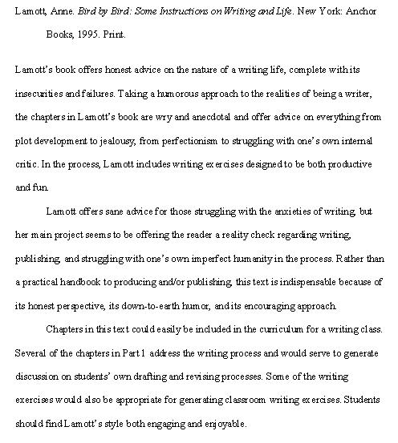
Printed materials – books, newspapers, magazines, journals
Online resources - books, newspapers, magazines, journals
Interviews
Video clips
Audio tapes
Speeches
Citing your sources in a bibliography should include information details such as:

Author’s name
Year of publication/production
Name or title of publication and or/article, or production
Place of publication/production
Name of publisher
If online resource, date it was downloaded or retrieved
Annotated Bibliography

When a bibliography is accompanied by annotations, it is called an Annotated Bibliography. Annotations are usually brief descriptions and evaluation of each source, to give the reader of the research paper, review or article a summary of different sources on a topic.

Here is a sample format to help students understand what is required in an annotation:

(Retrieved on April 27, 2014 from: https://owl.english.purdue.edu/media/pdf/20090309032047_614.pdf)

Annotated bibliographies first cite a specific source, followed by a brief description of the main ideas and comments about the source. It is important to know that these annotations do not represent a review of the source, as in a literature review discussed in the previous module. However, they are very helpful and serve as good guides when the researcher starts writing the Literature Review.

For annotated bibliographies, use standard APA format for the citations, then add a brief entry, including:

2 to 4 sentences to summarize the main idea(s) of the source:

What are the main arguments?
What is the point of this book/article?
What topics are covered?
1 or 2 sentences to assess and evaluate the source:

How does it compare with other sources in your bibliography?
Is this information reliable?
Is the source objective or biased?
1 or 2 sentences to reflect on the source:

Was this source helpful to you?
How can you use this source for your research project?
Has it changed how you think about your topic?
Important Reminder: Every time you take a note, be sure to write down all bibliographical information to include author, book title, article title, page numbers, volume number, publisher name and date.

As a closing note, to comply with APA formatting standards for your overall paper:

Your essay should be typed, double-spaced on standard-sized paper (8.5" x 11") with 1" margins on all sides. You should use a clear font that is highly readable. APA recommends using 12 pt. Times New Roman font. Include a page header (also known as the "running head") at the top of every page. To create a page header/running head, insert page numbers flush right. Then type "TITLE OF YOUR PAPER" in the header flush left using all capital letters. The running head is a shortened version of your paper's title and cannot exceed 50 characters including spacing and punctuation. Your essay should include four major sections: the Title Page, Abstract, Main Body, and References. For additional information on the essay structure, visit https://owl.english.purdue.edu/owl/resource/560/01/.

